Applications of Fuzzy Logic

In Boolean logic, everything is either true or false. If a situation is true then it is not false. There is an “absolute truth.” Boolean logic was traditionally used as a language to describe mathematical processes. Human reasoning does not use Boolean logic. Not everything is black or white. Some things are known with more or less certainty than others. And some things are known as certainly true or false.

Fuzzy logic is an extension of Boolean logic used to describe environments where there is no absolute truth and there is uncertainty.

Boolean logic- A system of logic that is based on Boolean algebra, named after George Boole. It deals with two truth values: ‘true’ and ‘false’. According to Boolean logic every statement one makes is either true or false with nothing in between. The Boolean conditions of true and false are often represented by 1 for ‘true’ and 0 for ‘false’. For example: the statement “Bob’s hair is blond” will either be true, Bob’s hair is blond or false, Bob’s hair is not blond. The statements one makes are called propositions. Logical operators are used to put together propositions. These operators include “and,” “or,” “not,” and “implication.” For example: A and B, A or B, A implies B. Statements are a combination of the proposition and the operators. The combined statements must also have a truth value. To define how a statement works the function of the operator must be defined. This can be shown with a truth table:

A | B | A and B | A or B | A => B
0 | 0 | 0 | 0 | 1
O | 1 | 0 | 1 | 1
1 | 0 | 0 | 1 | 0
1 | 1 | 1 | 1 | 1

The only case where implication A => B is false is when hypothesis A is true but conclusion B is false. In this case, the rule A => B is false because there is a “counter example” to the rule.

There exist many problems with Boolean logic. Human knowledge is not always black and white. For example: Joe is rich. This statement cannot be evaluated as just true or false. Different degrees of richness based on income exist. There are certain things that are not known as true or false.

Fuzzy logic- It is very easy to extend Boolean logic into multi-valued logic. Unlike Boolean logic, fuzzy logic is multi-valued and handles the concept of partial truth (truth values between ‘completely true’ and ‘completely false’). The first extension is trinary logic. In trinary logic there are three values instead of two. True (1), false (0), and ‘I don’t know.’ The truth tables for the logic operators are represented as follows:

A | B | A and B | A or B
0 | 0 | 0 | 0
0 | ½ | 0 | ½
0 | 1 | 0 | 1
½ | 0 | 0 | ½
½ | ½ | ½ | ½
½ | 1 | ½ | 1
1 | 0 | 0 | 1
1 | ½ | ½ | 1
1 | 1 | 1 | 1

Lucaziewitz said that trinary logic can be extended from three values to n values; where n can be any number. Professor Zadeh, University of California Berkley, introduced the theory of fuzzy logic; where the truth value of a statement can be any number from 0 to 1. Fuzzy sets are defined by a membership function. For example, consider the fuzzy sets “rich”,”young”. The certainty on how “rich” somebody is depends on his income. The more the income, the more certain it is that he belongs to the class of rich people. The property of “young” depends on his age. The smaller his numeric age in years, the younger he will be. These fuzzy concepts can be represented by the graphs given below.

Sometimes, instead of continuous graphs, a fuzzy set can be represented as an equation, if the domain is not continuous but discrete. For example, the fuzzy set “high grade” can be represented by the membership function:
M _{high grade} (grade) = 1.0/A + 0.7/B + 0.3/C + 0.1/D + 0.0/F.
In this notation, “+” means “or” and “x/y” means: “the membership value of y in the fuzzy set is x”.

The Boolean logic operators “and”,”or”, “not”, and “implication” can be extended in the case of fuzzy logic.

Young and Rich
Age 30 years old → truth is 0.7 based on the given membership function.
Income is 1,000,000 → truth is 0.99 based on the given membership function.

Then the truth of the fuzzy set “young and rich” is minimum (0.7, 0.99) = 0.7.

Young or Rich
The truth of the fuzzy set “young or rich” is maximum (0.7, 0.99) = 0.99.

Dice Numbers
Dice Number  x | C  m_{C}(x) | D  m_{D}(x) | E  m_{E}(x)
1 | 1 | 0 | 0
2 | 0.3 | 0.7 | 0.3
3 | 0.8 | 0.2 | 0.2
4 | 0 | 1 | 0
5 | 0.6 | 0.4 | 0.4
6 | 0.7 | 0.3 | 0.3

(a) C- favorite numbers
(b) D- disliked numbers
(c) E- both favorite and not favorite numbers

Logical Operation with Dice Numbers
Dice Numbers  x | F  m_{F}(x) | G  m_{G}(x) | H  m_{H}(x)
1 | 1 | 0 | 0
2 | 0.7 | 0.2 | 0.7
3 | 0.8 | 0.4 | 0.4
4 | 1 | 0 | 1
5 | 0.6 | 0.6 | 0.8
6 | 0.7 | 0.7 | 1
(a) F- either favorite or non favorite
(b) G- both big and favorite numbers
(c) H- both big and non favorite numbers

To define fuzzy implication consider the rule “IQ is high => grade are high”. Given the rule A => B, where A and B are fuzzy sets the membership function of implication is:
m_{A => B}(x,y) = max( 1-m_{A} (X), m_{B} (y))
↑↑
A B

For example, if the m_{grades = high}(x) = 1.0/A + 0.7/B + 0.3/C + 0.1/D + 0.0/F and
m_{IQ = high}(y) = 0.1/100 + 0.3/110 + 0.5/120 + 0.7/130 + 0.8/140 + 0.9/150 then the membership function of implication is:

Grades
 | A | B | C | D | F
100 | 1 | 0.9 | 0.9 | 0.9 | 0.9
110 | 1 | 0.7 | 0.7 | 0.7 | 0.7
120 | 1 | 0.7 | 0.5 | 0.5 | 0.5
130 | 1 | 0.7 | 0.3 | 0.3 | 0.3
140 | 1 | 0.7 | 0.3 | 0.2 | 0.2
150 | 1 | 0.7 | 0.3 | 0.1 | 0.1

IQ
Score
If rule: IQ = high => grade = high and a student with IQ = 150 has grade = A, by table
m_{rule}(150,A) = 1. This is an example of the rule. But if the student has IQ = 150 and grade = F, by table m(150,F) = 0.1.This is close to 0, so this student tends to be contradictory to the rule.

INTRODUCTION

Fuzzy logic is a problem solving control system methodology that lends itself to implementation in systems ranging from simple, small, embedded microcontrollers to large, networked, multi channel computers or workstation based data acquisition and control systems. It can be implemented in software, hardware or both. It provides a simple way for arriving at a definite conclusion based upon ambiguous, imprecise or missing input information.

Fuzzy logic requires some numerical parameters in order to operate such as what is considered significant error and significant rate of change of error, but exact values of these numbers are usually not critical unless very responsive performance is required in which case empirical tuning would determine them.
Many control problem use Fuzzy logic because it offers several unique features:
1) It is inherently robust since it does not require precise, noise free inputs and can be programmed to fail safely if a feedback sensor quits or is destroyed. The output control is a smooth control function despite a wide range of input variations.
2) It can be modified and tweaked easily to improve or drastically alter system performance, since the controller processes user defined rules governing the target control.
3) Any data sensor that provides some indication of a system's actions and reactions is sufficient. This allows the sensors to be inexpensive and imprecise thus keeping the overall system cost and complexity low.
4) Because of the rule based operation, any reasonable number of inputs can be processed and numerous outputs generated, although defining the rule base quickly becomes complex if too many inputs and outputs are chosen for a single implementation since rules defining their interrelations must also be defined.
5) It can control nonlinear systems that would be difficult or impossible to model mathematically. This opens doors for control systems that would normally be deemed unfeasible for automation.
1-1: Applications of Fuzzy logic: -
- Control trains in Japan using fuzzy controllers.
- Cement Kiln controller.
- FLOPS is a fuzzy ES rule based shell.
- Z-II is a fuzzy ES shell used in medical diagnosis and risk analysis.
- Fuzzy logic has been applied in video camera technology for automatic focusing, automatic exposure, image stabilization and white balancing.
- Fuzzy logic has been applied in automobiles for cruise control, brake and fuel injection systems.
- Fuzzy algorithms have been applied for video and audio data compression.
1-2: Steps to use Fuzzy logic: -
1) Define the control objectives and criteria by knowing what to control, how the system can be controlled, kind of response needed and possible system failure modes.
2) Determine the input and output relationships and choose a minimum number of variables for input to the engine.
3) Using the rule based structure of fuzzy logic, break the control problem down into a series of IF X AND Y THEN Z rules that define the desired system output response for given system input conditions. The number and complexity of rules depends on the number of input parameters that are to be processed and the number fuzzy variables associated with each parameter. If possible, use at least one variable and its time derivative. Although it is possible to use a single, instantaneous error parameter without knowing its rate of change, this cripples the system's ability to minimize overshoot for a step inputs.
4) Create membership functions that define the meaning of input and output terms used in the rules.
5) Create the necessary preprocessing and post processing routines if implementing in software, otherwise program the rules into the hardware engine.
6) Test the system, evaluate the results, tune the rules and membership functions, and retest until satisfactory results are obtained.
1-3: Membership Functions: -
The membership function is a graphical representation of the magnitude of participation of each input. It associates a weighting with each of the inputs that are processed, define functional overlap between inputs, and ultimately determines an output response. The rules use the input membership values as weighting factors to determine their influence on the fuzzy output sets of the final output conclusion. Once the functions are inferred, scaled, and combined, they are defuzzified into a crisp output which drives the system. There are different membership functions associated with each input and output response. Some features to note are:
Shape: triangular is common, but bell, trapezoidal and exponential have been used. More complex functions are possible but require greater computing overhead to implement.
Height or magnitude: is usually normalized to 1.
Width: is of the base of function.
Shouldering: locks height at maximum if an outer function. Shouldered functions evaluate as 1.0 past their center.
Center: points center of the member function shape.
Overlap: typically about 50% of width but can be less.
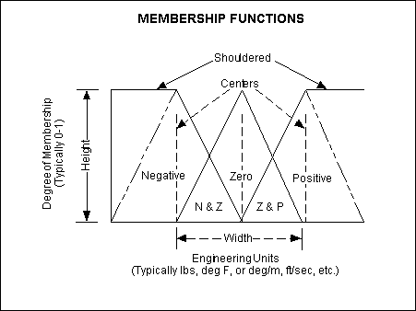

fig. 1-1:The features of a membership function

Figure above illustrates the features of the triangular membership function which is used in this example because of its mathematical simplicity. Other shapes can be used but the triangular shape lends itself to this illustration.
The membership of an element in a fuzzy set is often quantified by such quantifiers as: very, more or less, quite an so on.

The membership function can be defined for them to express their meaning.
for example:
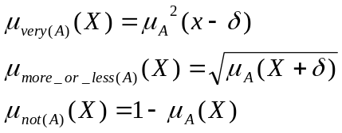
where δ is a focus shifting constant

A fuzzy set is some times called a type 1 fuzzy set. A type 2 fuzzy set is the one whose membership degrees are type 1 fuzzy sets.

1-4: Operations on fuzzy sets: -
There are many definitions for the operations of union, intersection, implies and Cartesian product. The most commonly used are:
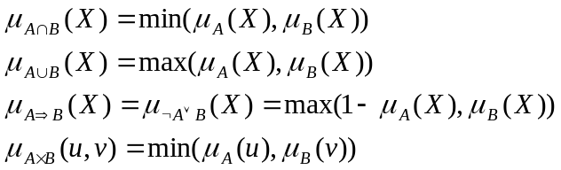

1-5: Fuzzy implications: -
A fuzzy implication is of the form: IF X is A THEN Y is B, where A, B are fuzzy sets defined on a universal sets 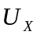and 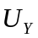 respectively.
The definition of the truth table of a fuzzy implication should be a generalization of Boolean case. That is, if the condition “X is A” is satisfied with a degree of membership 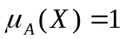 and “Y is B” with a membership degree of 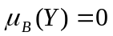, then the truth value of the implication 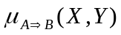should be equal to 0, if 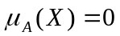 and or if and 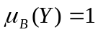 then =1.
Many alternate definitions of fuzzy implication exist. Some of these membership functions are:

(Reichenbach)
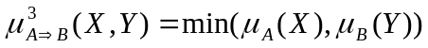 (Willmot)
(Mamdani)
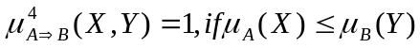
and 0 otherwise (Rescher-Gaines)
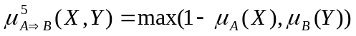 (Klene-Dienes)

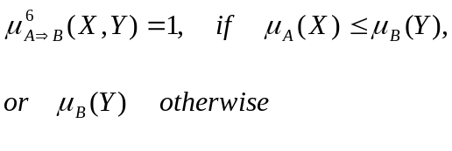(Brouwer-Godel)

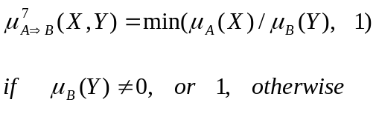

(Gorgen)

Given the rule IF X is A THEN Y is B, and Given X is A’, a conclusion Y is B’ can be reached. The membership of B’ is defined in a way that if A=A’ then 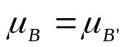. It is done as follows:

Given the membership function of A’, 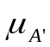, the membership of the fuzzy set B’ is given by:
(1)
i=1, 2, 3, 5, 6, 7, 8 we have that the desired property,( if A=A’ then ) holds.
Another formula is :
(2)
i=3 or 6.

