1) Defined new site in Dreamweaver.
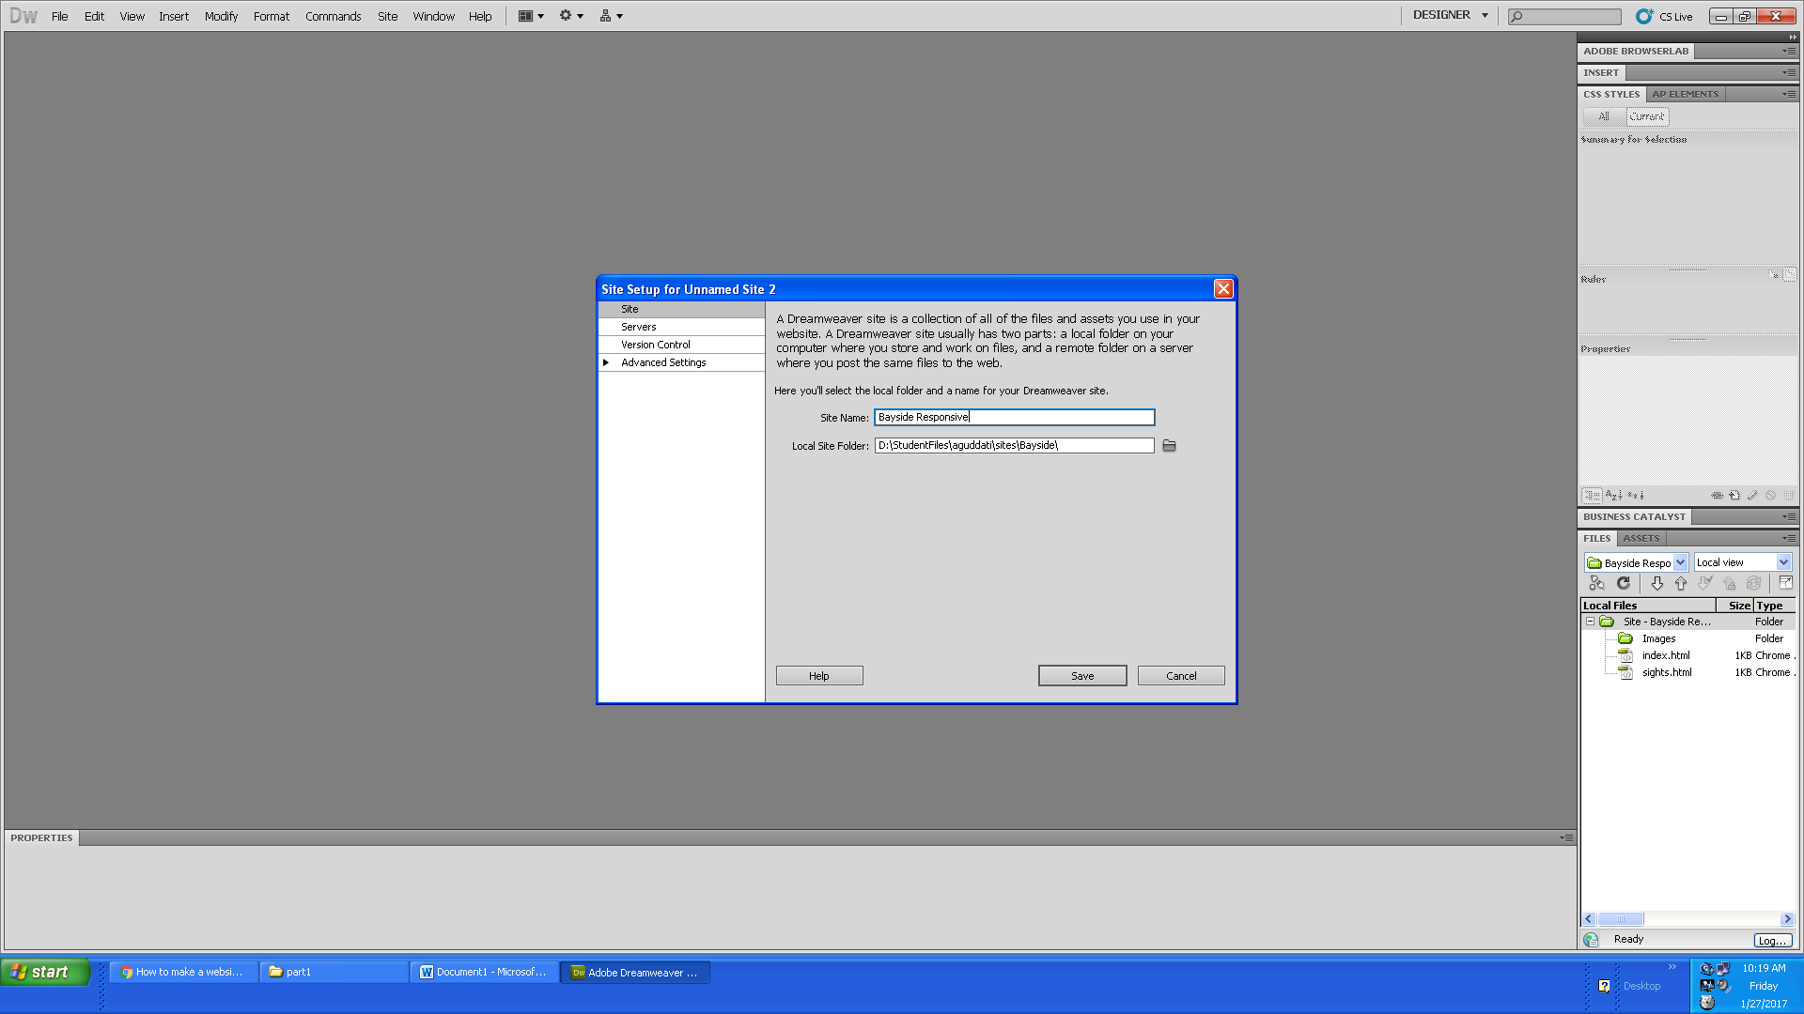

2) Created a new folder for Images which are used in Website creation.
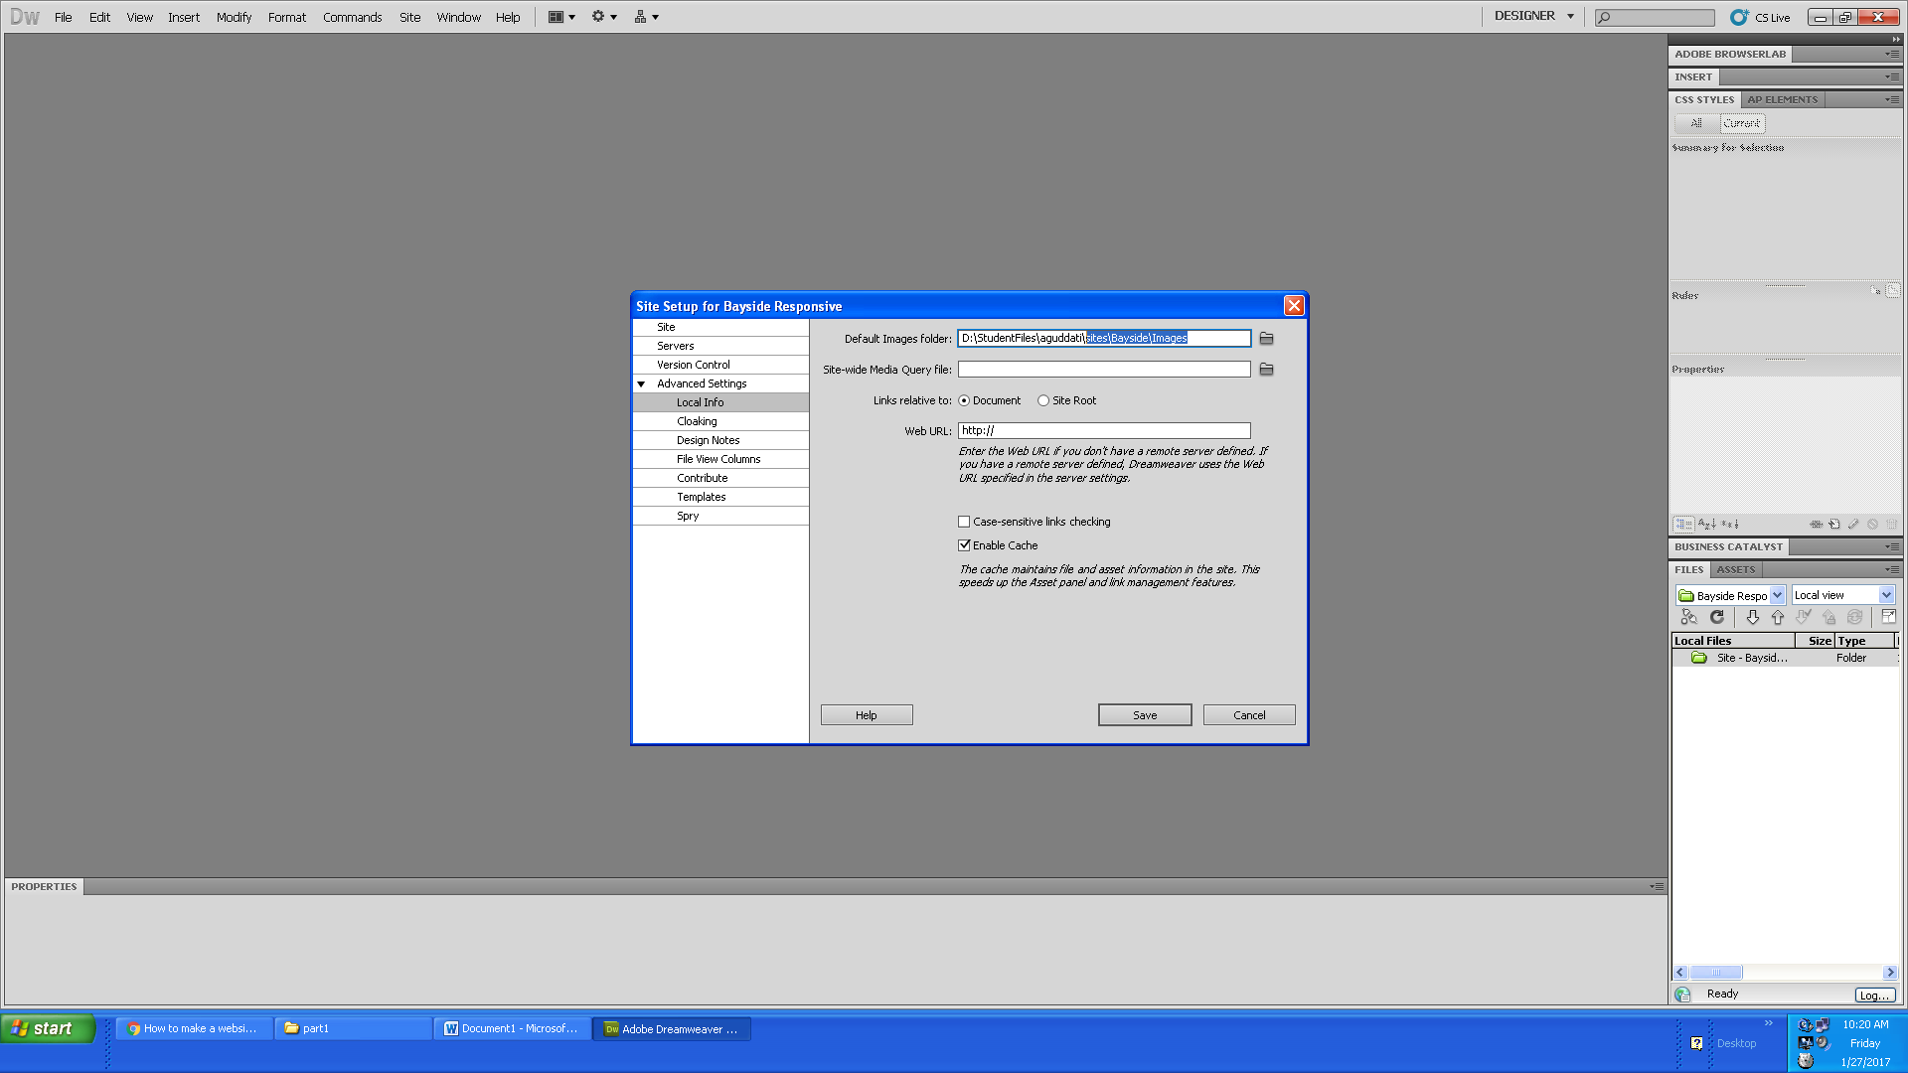

3) Created a blank webpage and named it as index.html
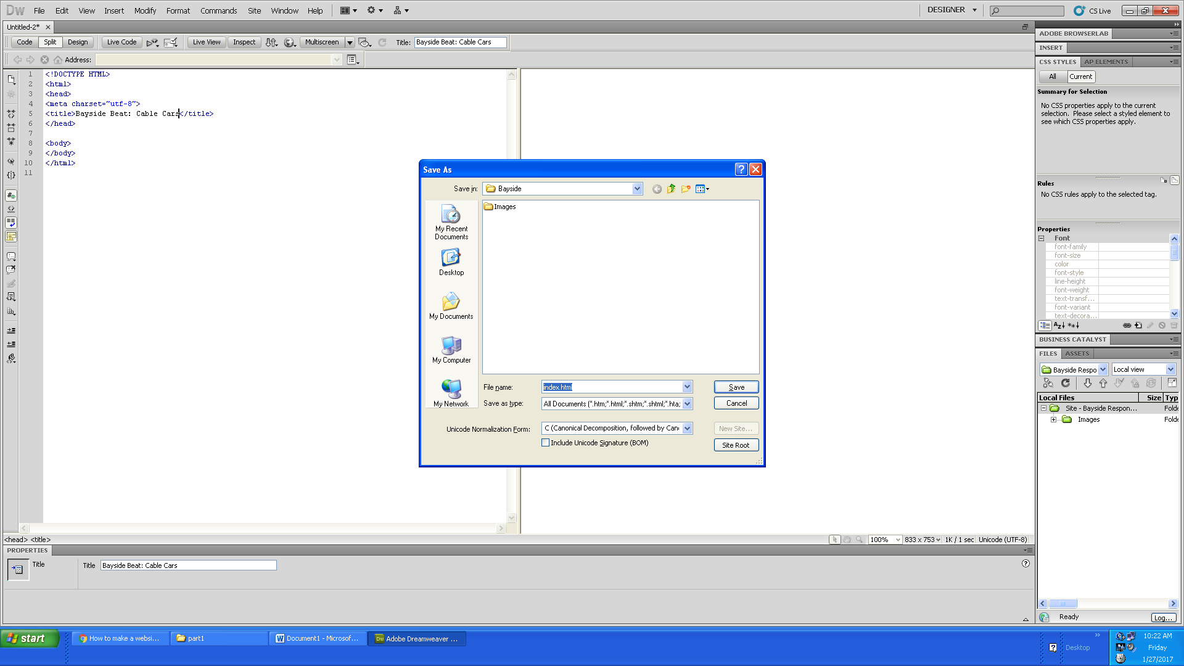

4) Created another webpage and named it as sights.html and saved in the root folder Bayside.
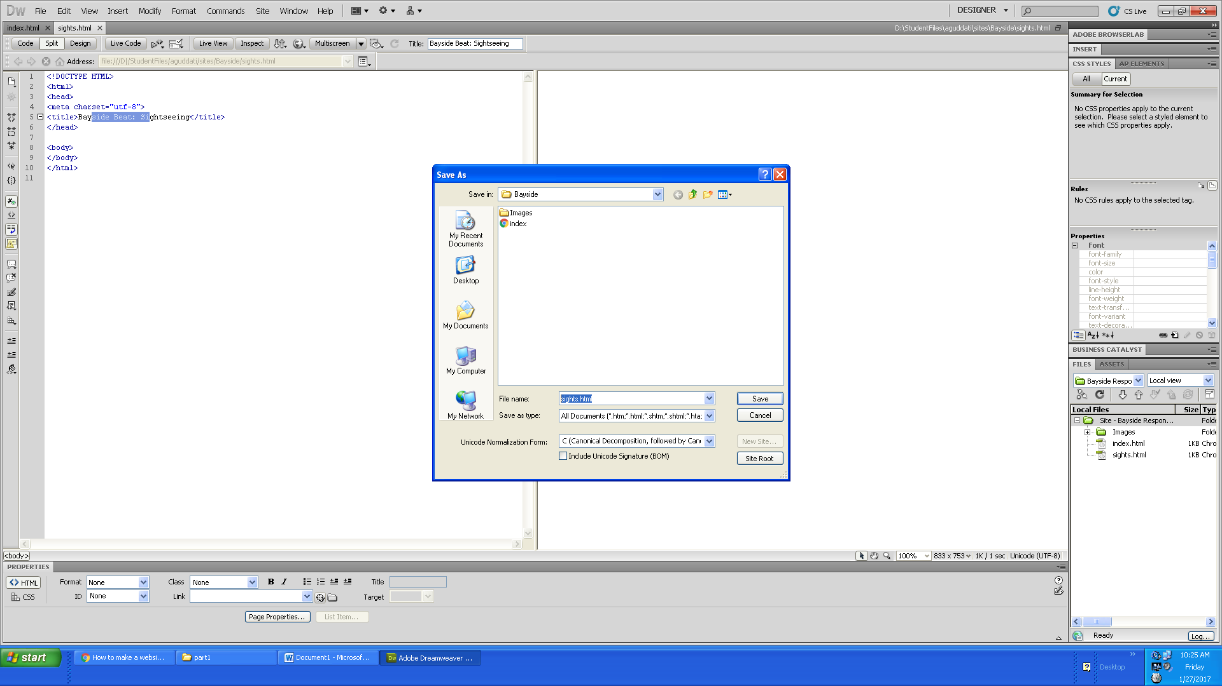

5) Split view between code and Design.
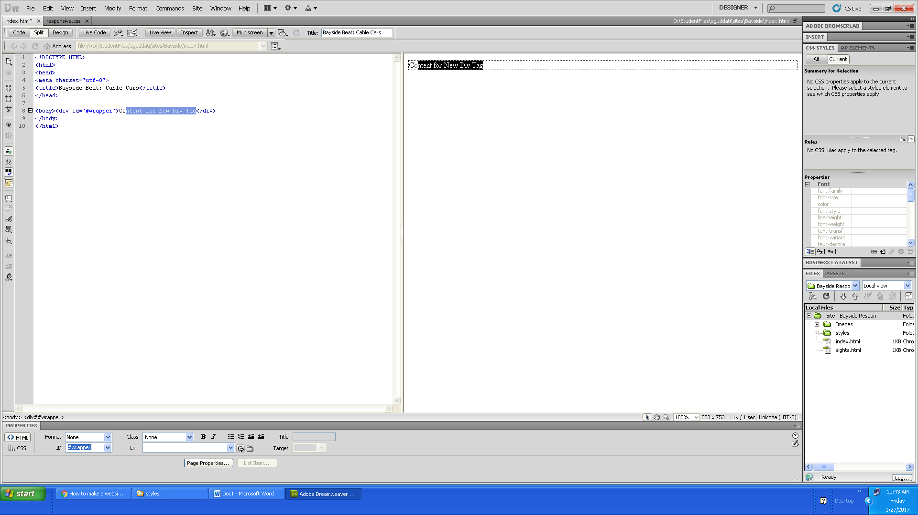

6) Created a new CSS file in root folder and named it as responsive.css/or main.css.
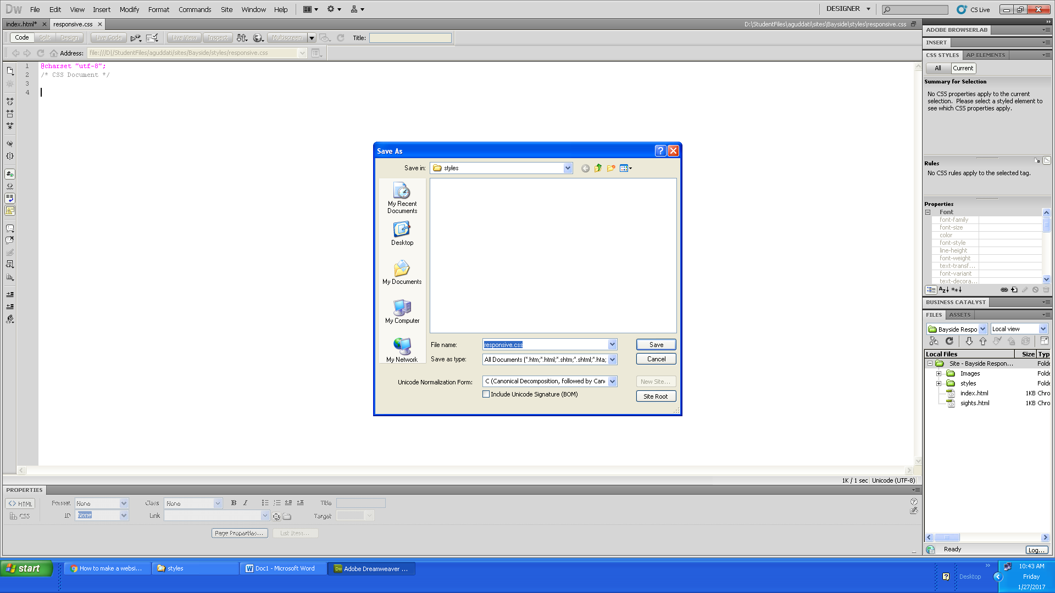

7) Added content directly into the live view.
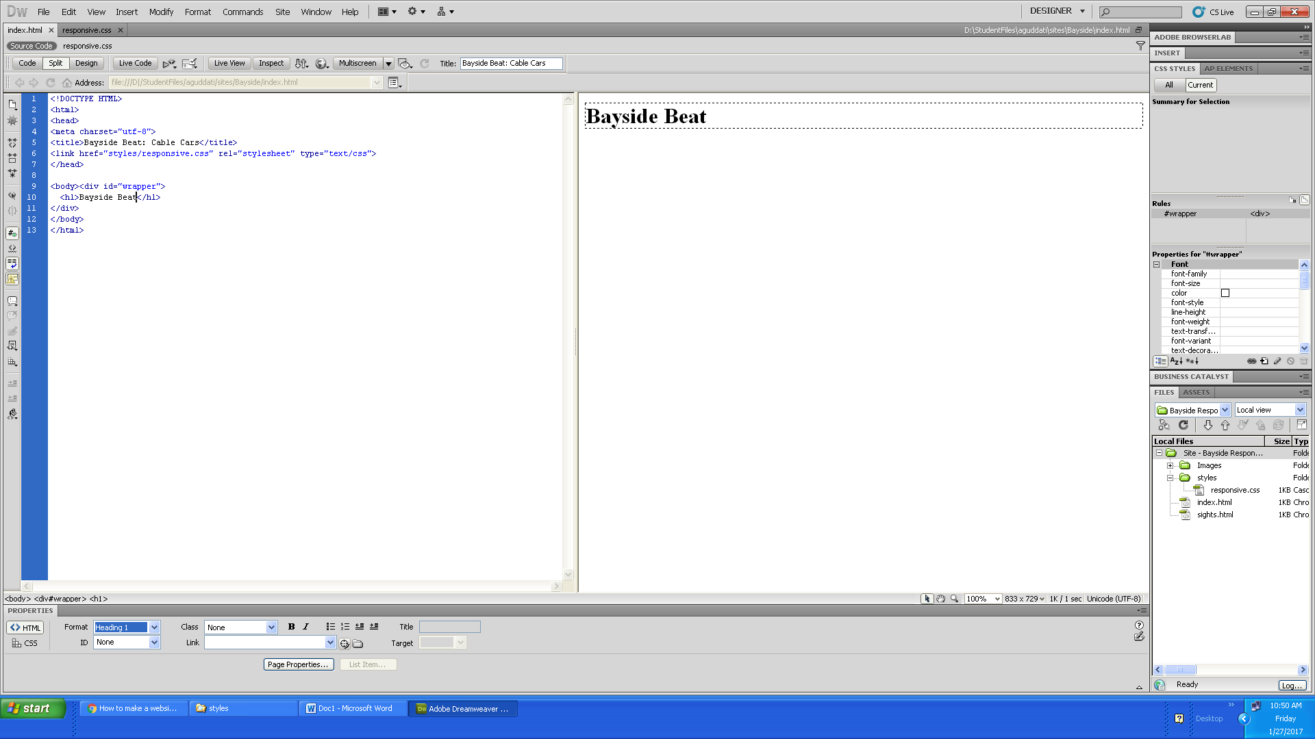

8) Created a list and edited content in live view.
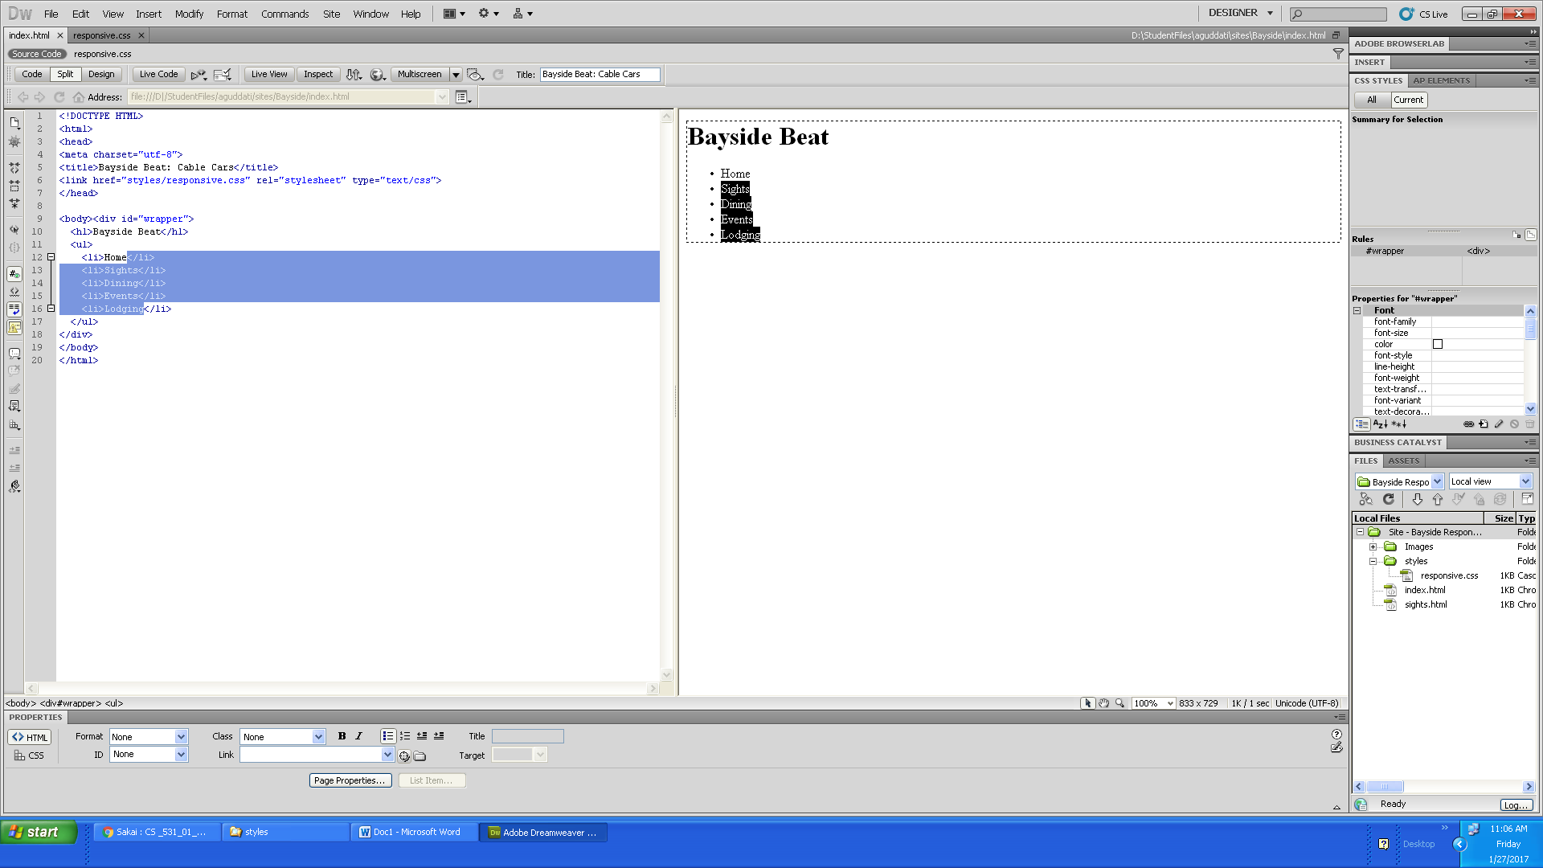

9) Copied the content from word into the index.html webpage.
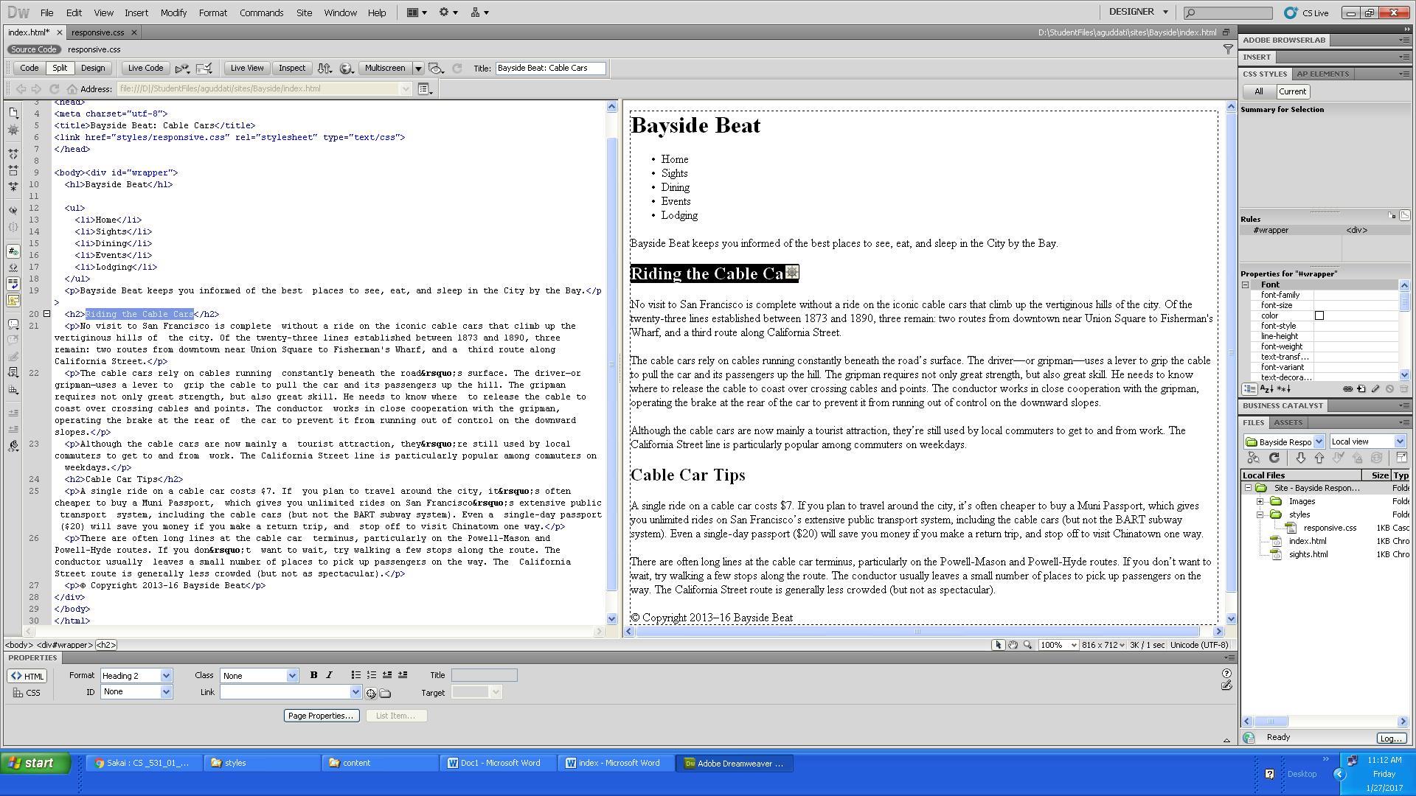

10) Created a new snippet (right-click to bring up the menu).
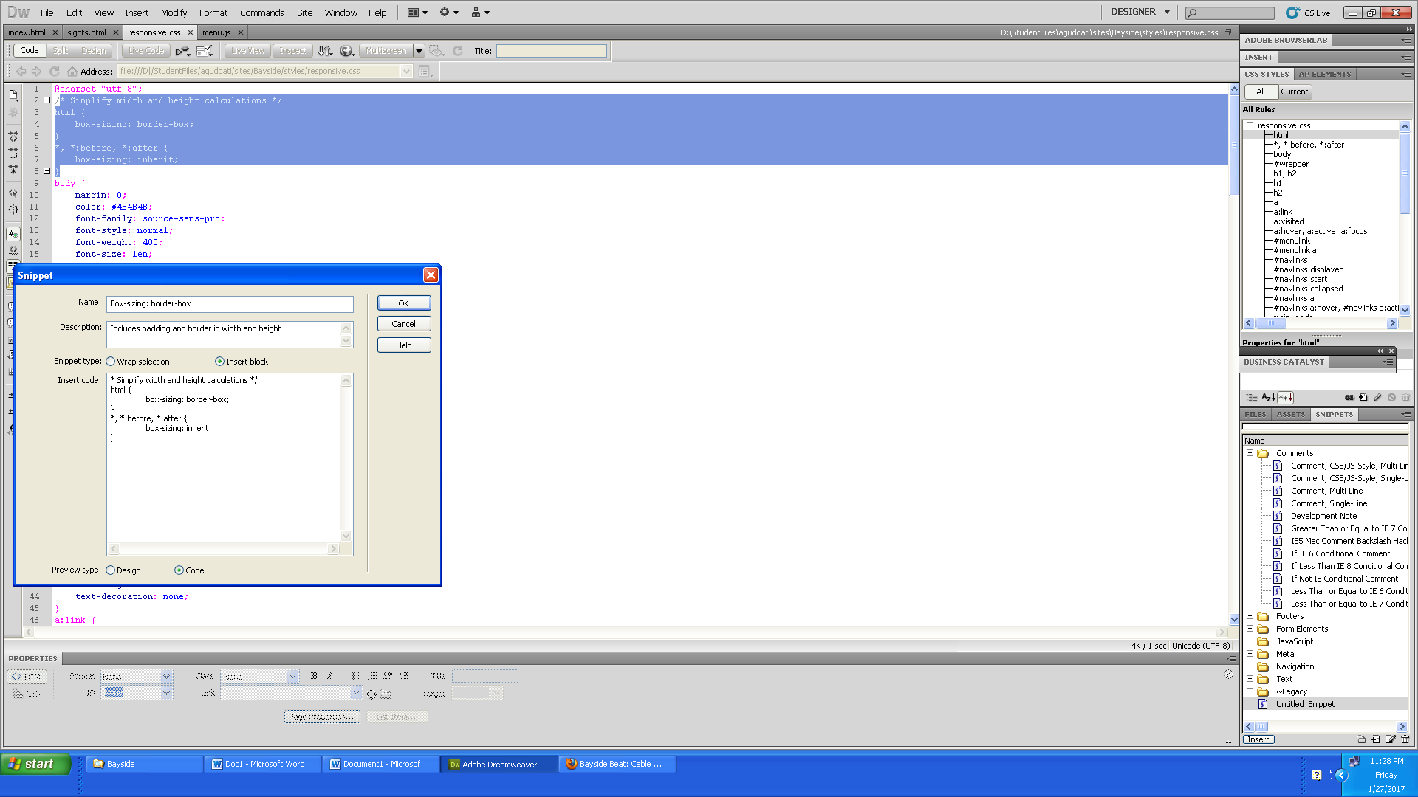

11) Adding selectors (DOM panel) and setting properties to the content.
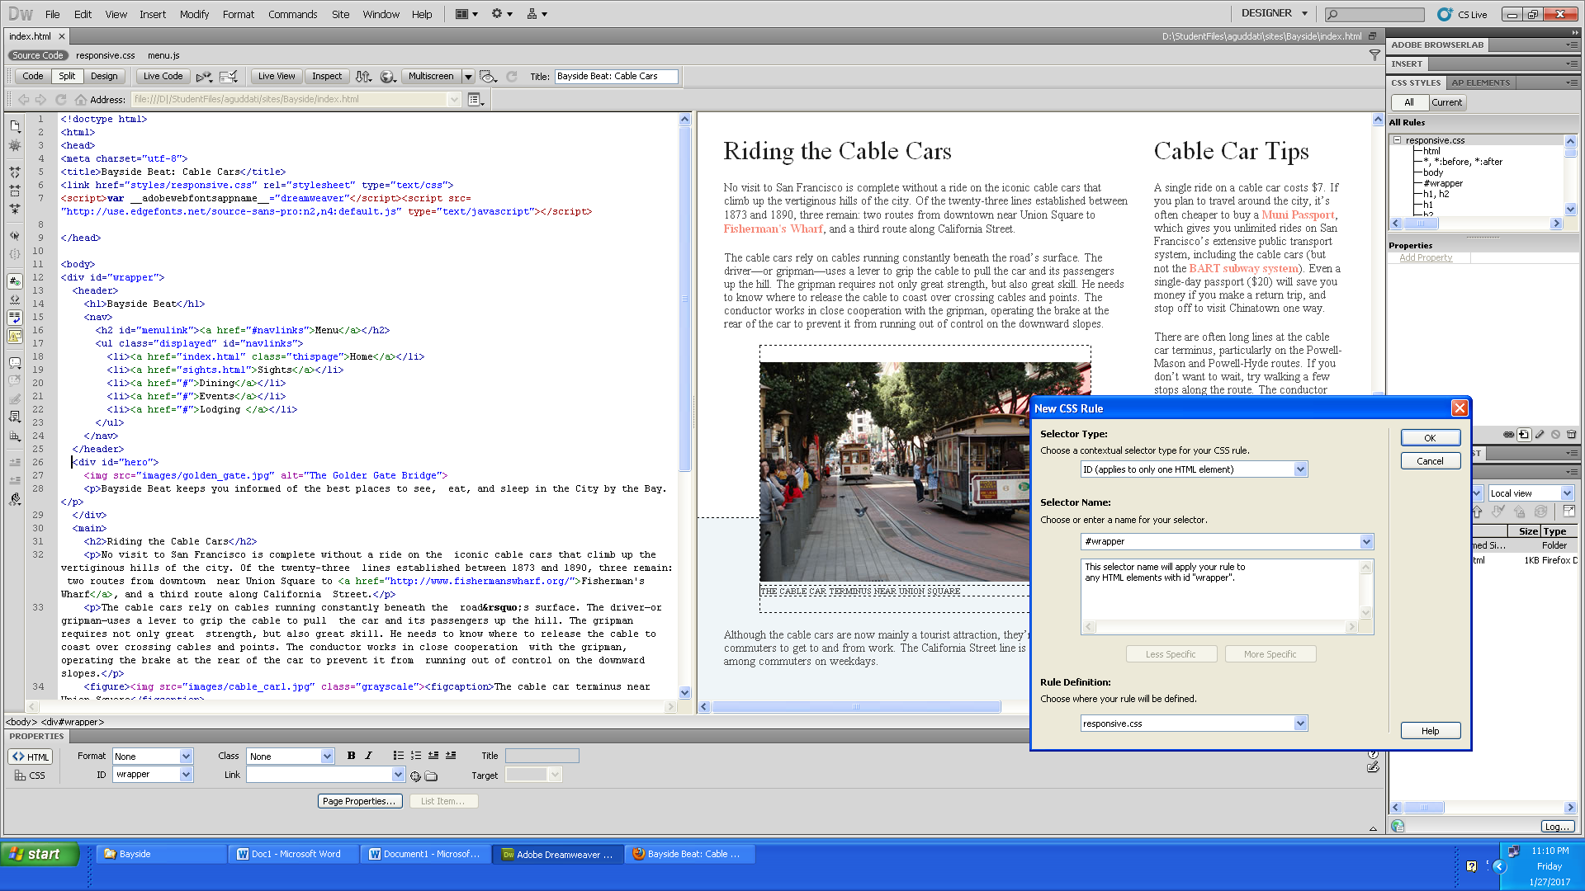

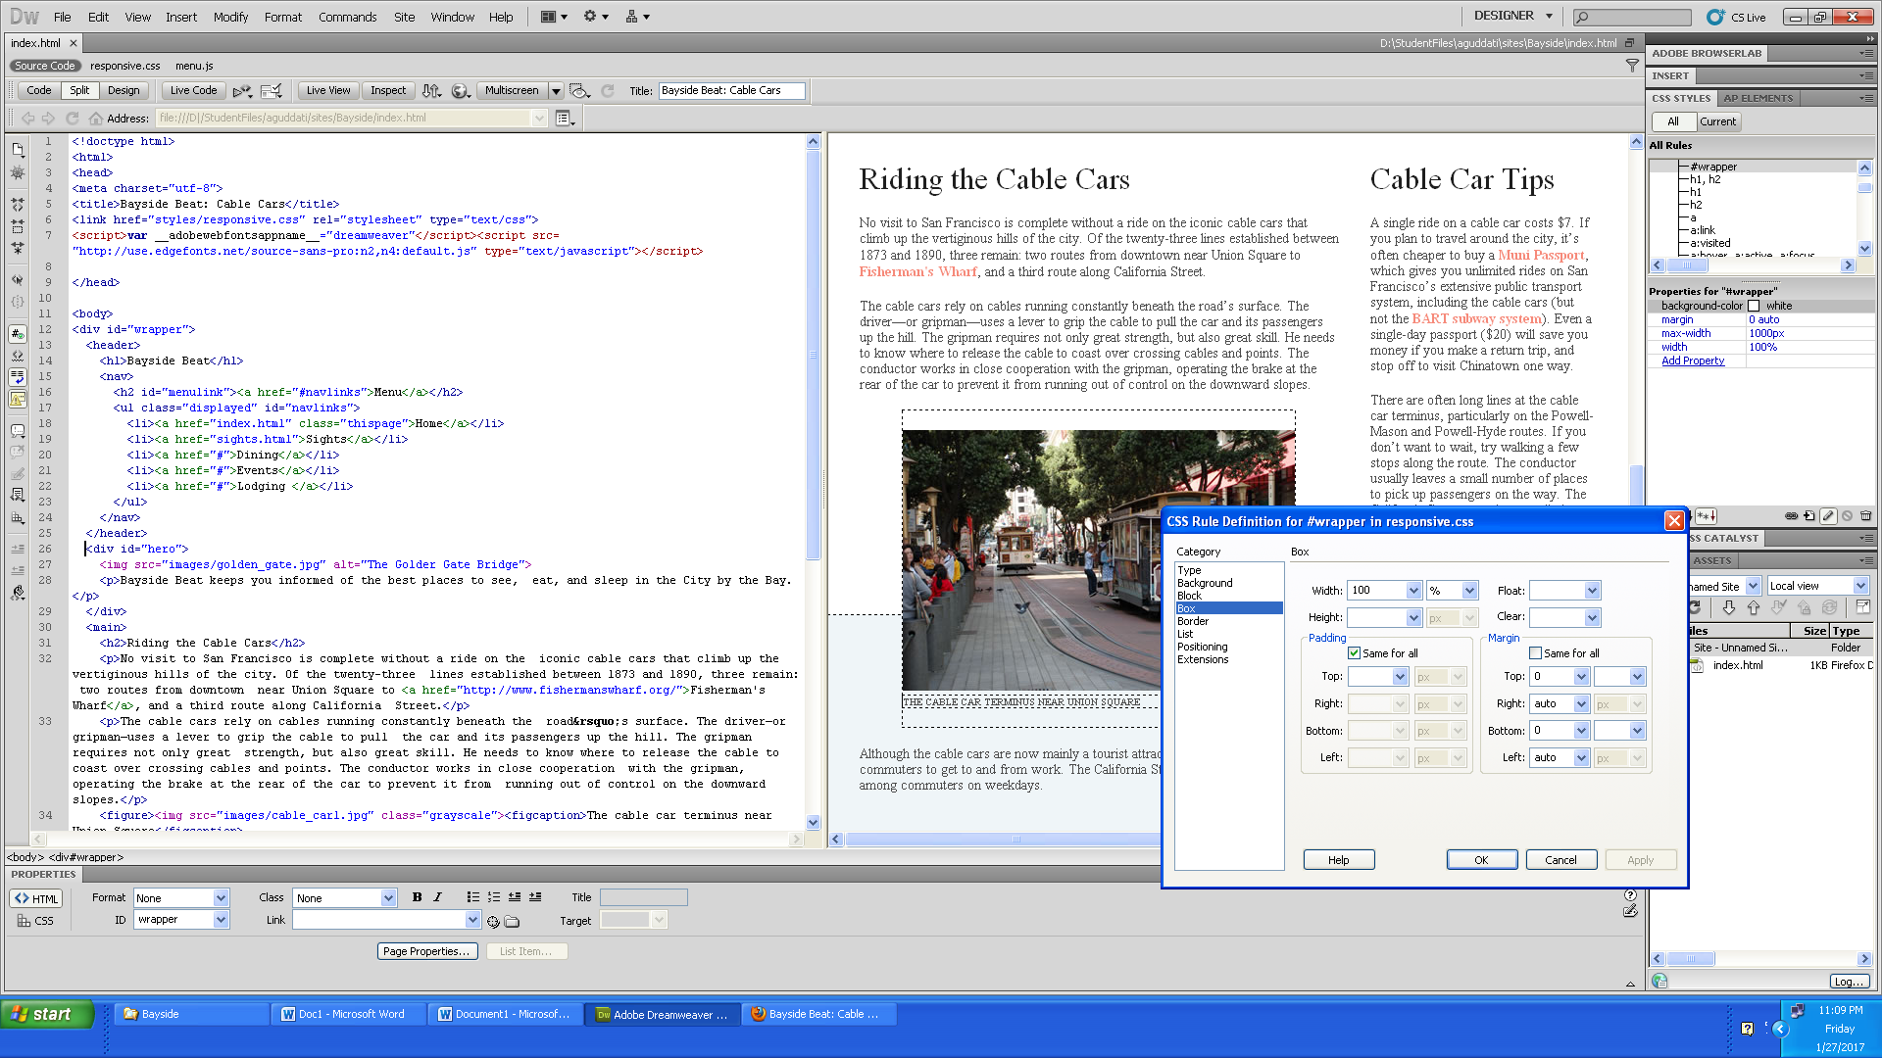

12) Added selectors and properties in the responsive.css or main.css (you may cut and paste from the css file from the completed subdirectory part7 in make-website.zip)

13) Copied the content from word (or html file from completed directory part7 in make-website.zip) into the sights.html webpage.
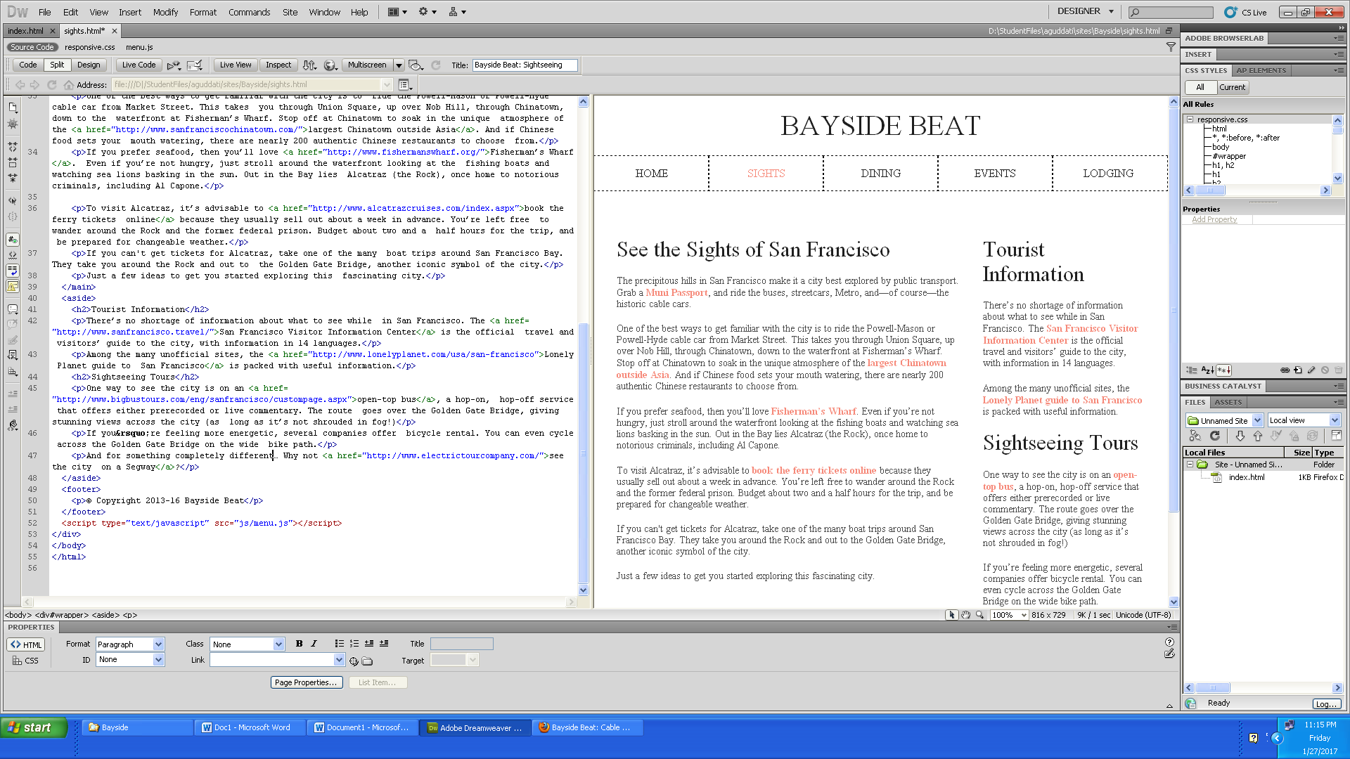

14) Inserting Images to webpage from images folder.
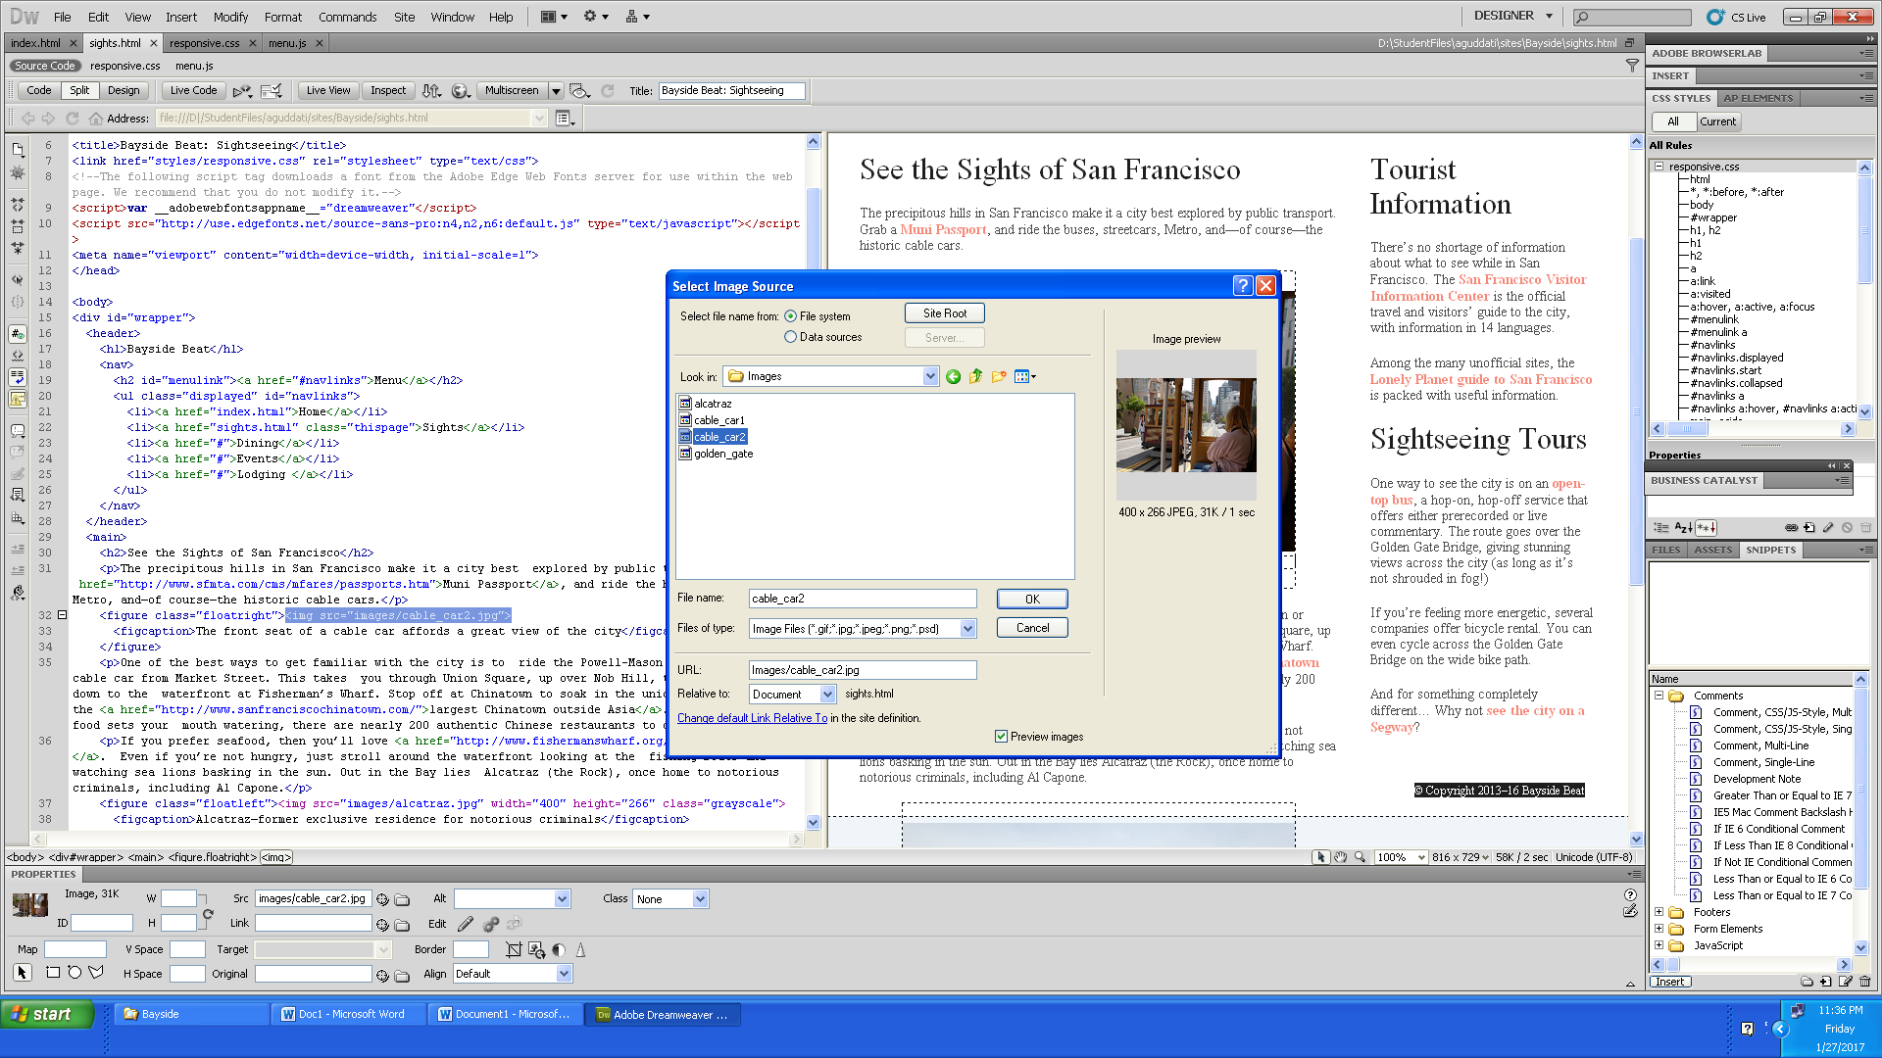

15) Styling links for navigation between webpages.
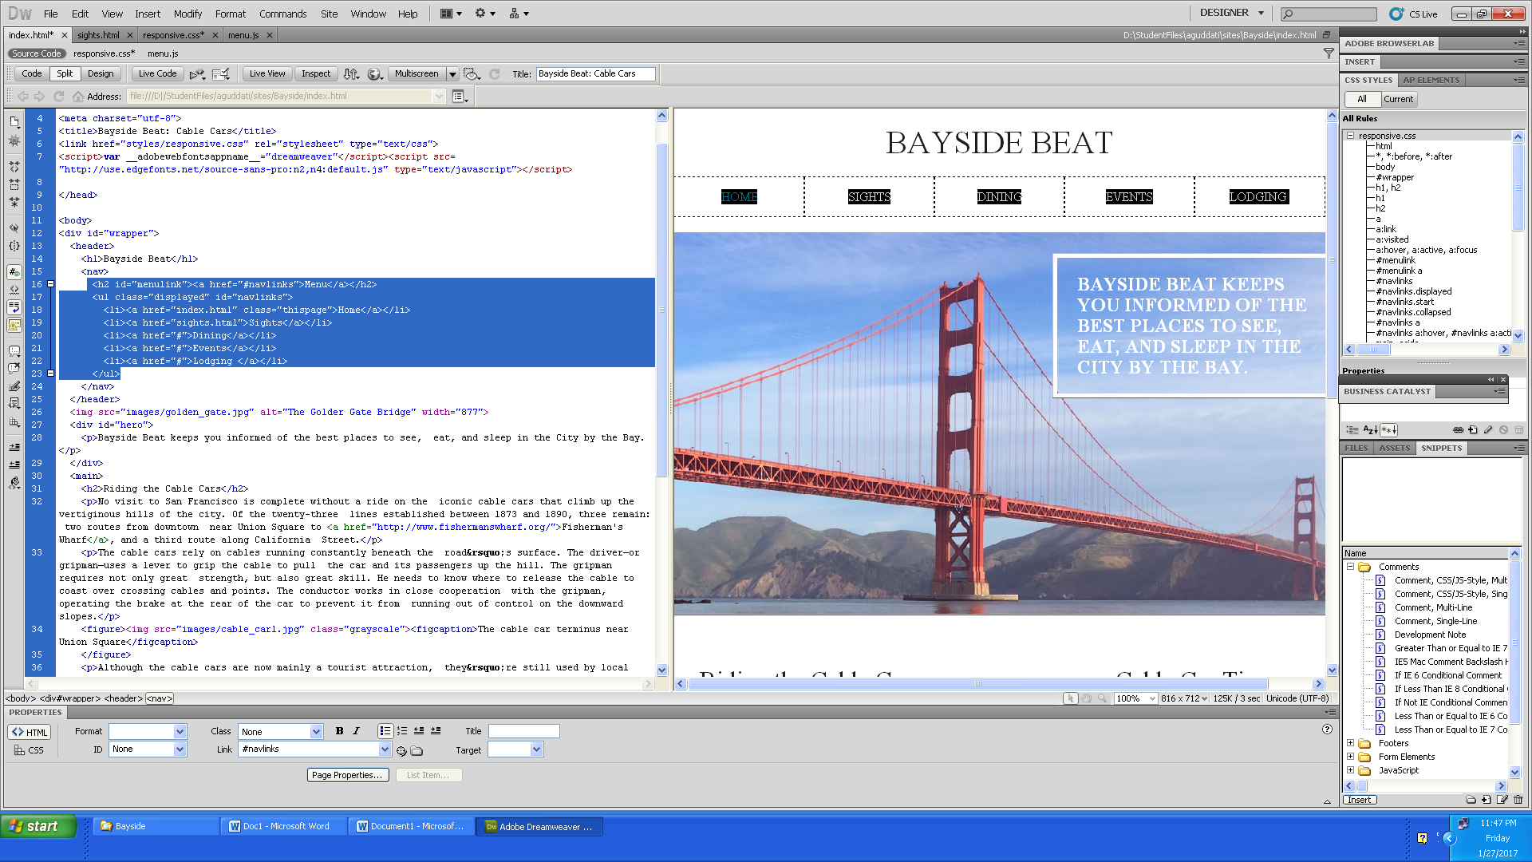

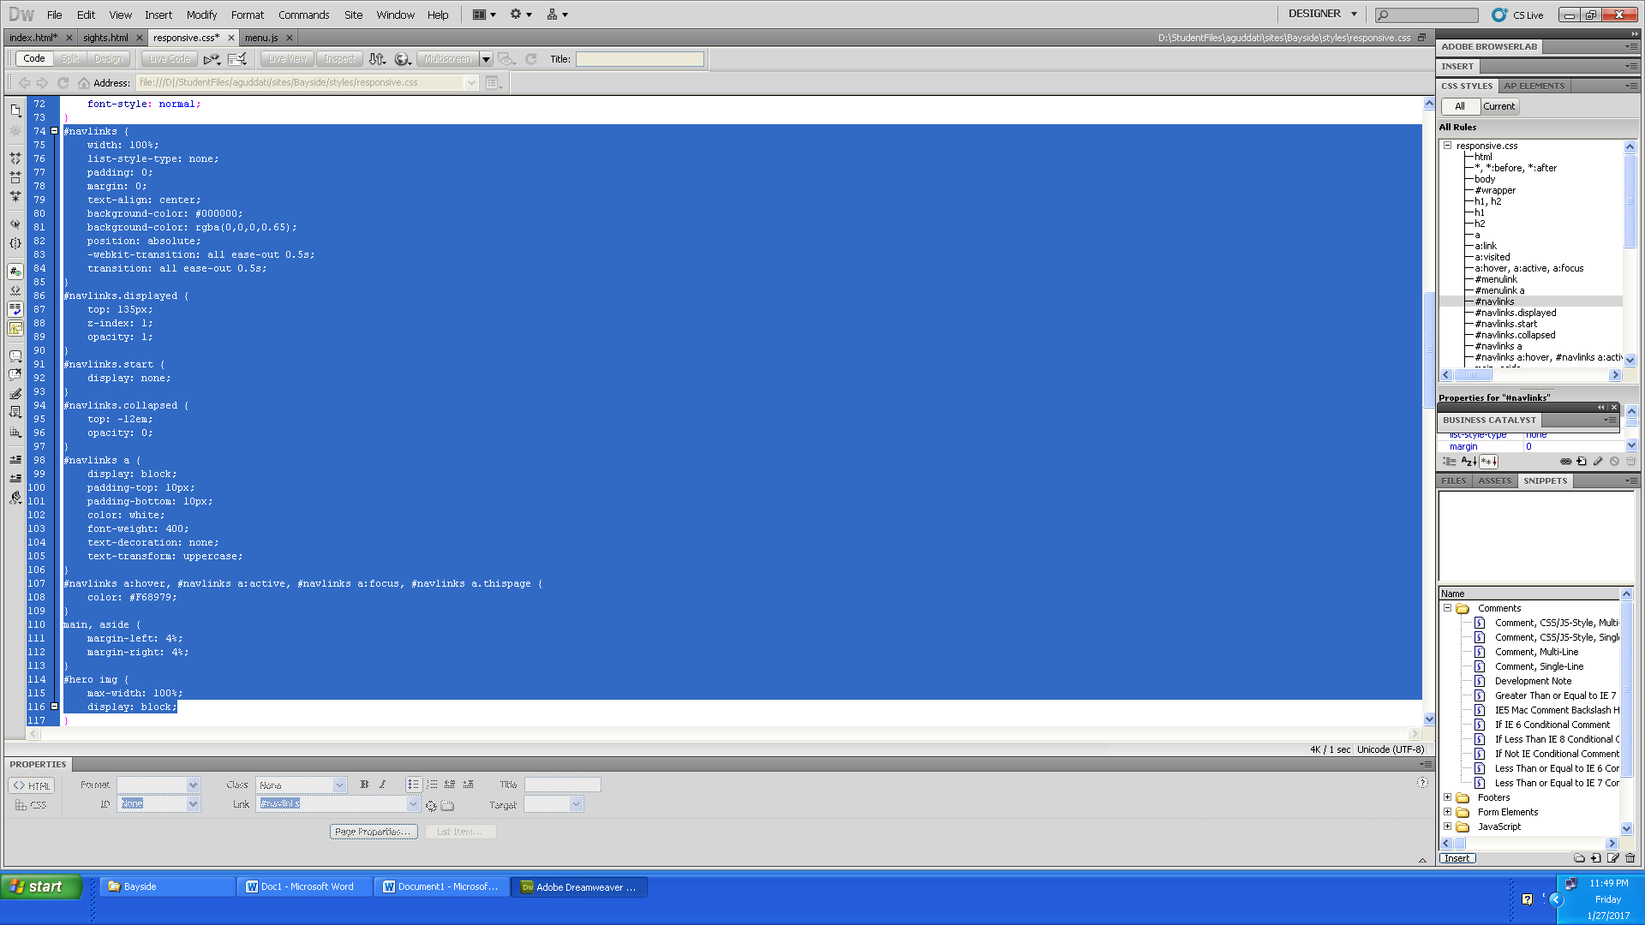

16) Final output in the browser.
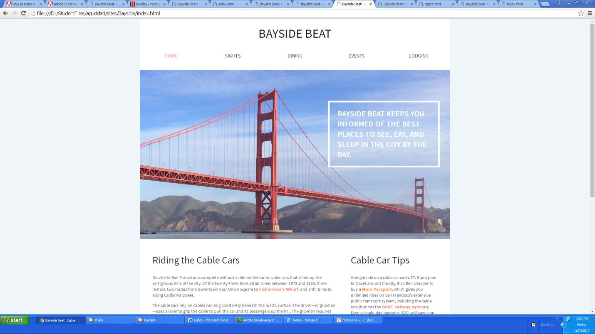

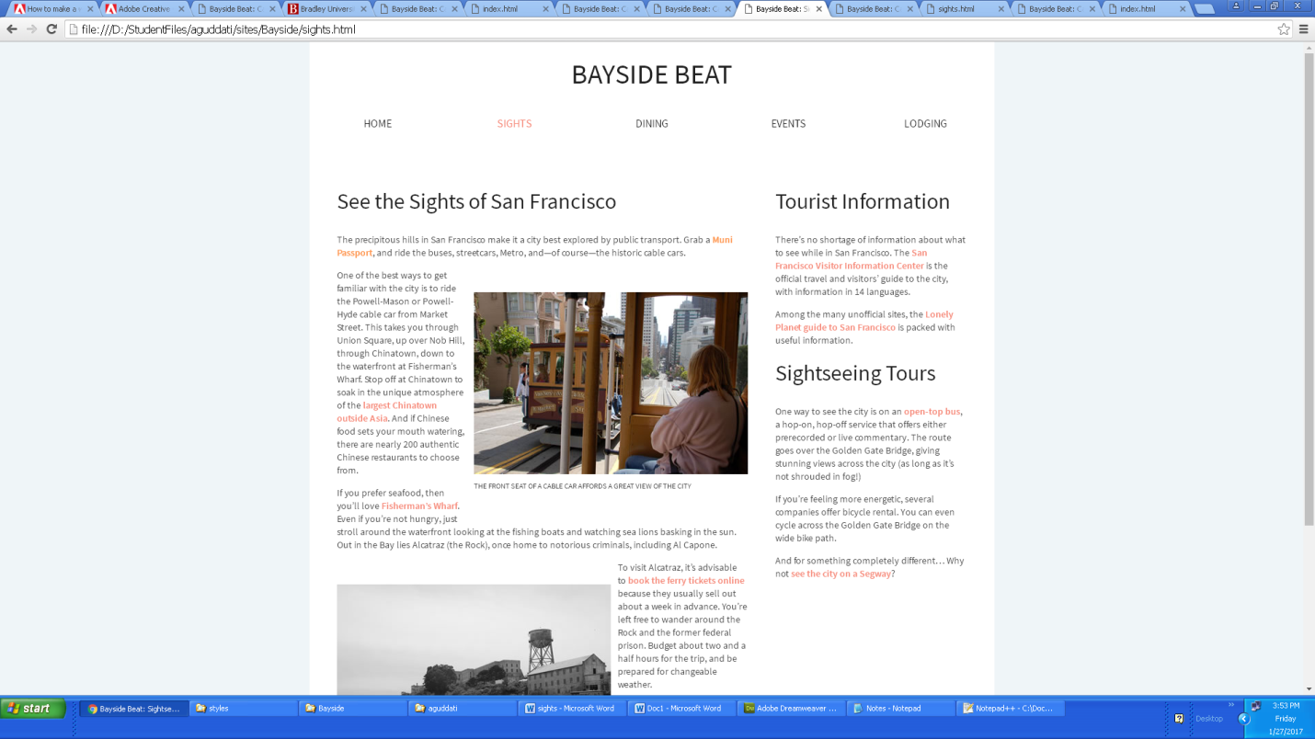

NOTE: Some features which are not available in the DreamWeaver CS 5.5
- DOM panel is not available to edit the selectors.

- Some properties are not available in old version we have to write manually. And some tags are not available in the insert option.

